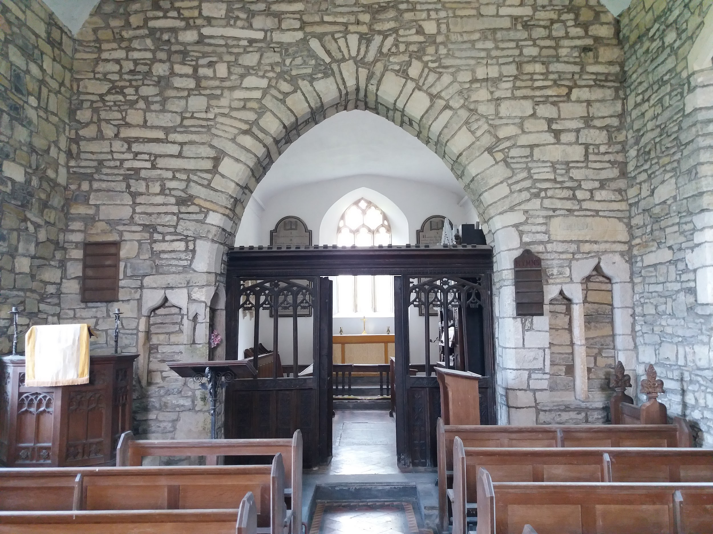

**ALL SAINTS’ CHURCH OTTERHAMPTON**

AUG 2023 CHURCH PLAN

A recent meeting took place at All Saints Church in Otterhampton, with the local representative of the Churches Conservation Trust and three members of the local community to discuss the possible future of this church. Below is a summary of information and discussions from the meeting.

All Saints Church in Otterhampton, Somerset, dates from the 14th century. It is recorded in the National Heritage List for England as a designated Grade II listed building.

A church was established on the site in the 12th century, valued at £5 in 1291, although the current building largely dates from the 14th. The Perpendicular west tower was added later and has an Elizabethan bell-frame with 4 bells, one of which dates from the 16th century and two others are dated 1617 and 1737. The original dedication was to Saint Peter, however it was later renamed All Saints.

The interior includes a Norman font with a Jacobean cover, a screen from the 16th century, and 17th-century communion rails.

It was declared redundant on 1 March 1988, and was vested with the Churches Conservation Trust on 2 August 1989.

All Saints currently has permission from the Church of England for up to six Sunday services each year, plus an unlimited number of occasional services. In the past two years the Church has hosted one evensong service and one funeral.

CCT are very grateful for the support of the incumbent, and also the Area Volunteer who carries out building condition checks and empties the wall safe.

Voluntary activity undertaken includes:

Looking after the keys

Completion of bi-annual site inspection forms

Remittance of wall safe and service funds

Planning and delivery of services

Ad hoc reporting of building change

The Local Community Officer (LCO) also completes regular mandatory checks and actions, including regular Control of Substances Hazardous to Health (COSHH) checks, visual electrical inspections, Fire Risk assessments and Building and General Risk Assessments. In addition the church also receives two maintenance visits per year from CCTs specialist maintenance contractor and detailed Condition Reports from the allocated Architect.

**Summary of community consultation meeting 1**

A Church Plan meeting was held at Otterhampton All Saint’s Church on Friday 4th Aug 2023. Present were the Local Community Officer (LCO) and 3 members of the community

**1. Services and Events**

There historically is one service a year at All Saints church. The LCO had spoken to the local incumbent before the meeting and a service was happening on Sunday 6th August. Apart from occasional visiting bell ringers no other events happen at Otterhampton but there was interest with regards to holding a concert or possibly a flower festival next year.

**2. Walking Routes**

The group mentioned that All Saints is on a walking route. The route that runs from near All Saints to Otterhampton School is called ‘Coffin Way’ and could potentially be part of a circular walk linking with Combwich and Stockland.

**3. Maintenance Issues**

Part of the plaster ceiling in the vestry has collapsed and there is lots of dust and cobwebs in the nave. The LCO suggested a cleaning day, which would be worth having if an event or service is taking place at All Saints. The local incumbent had mentioned roof tiles missing from the nave the day before the meeting.

**Action Plan**

**Community Action**

* Inform LCO of the contact details for someone at Somerset CC who could potentially help with promoting a walking route.

**Local Community Officer Immediate Actions**

* LCO to report fallen roof tiles to Estates Officer (EO).
* LCO to find out whether the bell tower is still open for bell ringing and if there is an insurance policy for members of the public to go up into the bell tower.
* LCO will keep the group informed about a potential concert at All Saints next year.

**Local Community Officer & Community Medium Long term Actions**

* Investigate potential for scheduled cleaning days
* Investigate options for recruiting additional volunteers and community members, particularly for organising events, activities and services, and for general fundraising
* Consider means for increasing additional public interest, footfall and consequent donations
* Investigate possibility of one or two church services a year
* Review methods for promoting church to historical, archaeological or ecological societies, and inclusion in local heritage trails or walking/cycling routes.
* Consider the suitability of the site for Champing
* Identify means and suitability of Christmas card sales
* Consider potential for introduction of venue to prospective new participants for events, hires, group visits etc
* Investigate participation in Ride & Stride scheme
* Investigate musicians, artists, theatre companies or poets who might wish to use the church
* Discuss potential for regular church related features, parish newsletter and inclusion of church updates in parish council meetings
* Contact nearby Hill House Christian Centre to investigate whether they would be interested in using the church
* Investigate links into the Everard family to see if they are interested in becoming involved with the church (if still local)
* Identify means and suitability of Christmas card sales

## Local Community Officer’s Summary

It would be lovely to build closer links with the local community and to get more activity happening at All Saints’. The church would also definitely benefit from a cleaning day.

Unfortunately as there is currently a large gap between the existing income and the annualised maintenance costs, we would need to explore income-generating activities.

The possibility of one or two church services a year would increase visitor numbers, and provide an opportunity to raise awareness of the annualised maintenance costs, and to encourage collection contribution. Updates to the parish newsletter and inclusion of church reports at parish council meetings could also highlight the annualised maintenance costs.

Additional promotion of upcoming services and events via the Parish newsletter and at parish council meetings, on the CCT website, in CCT newsletters and in other locations would be useful.

Other activities and events the community could consider to raise additional income are tea parties, musical concerts, poetry evenings, theatre performances, lecture or speaker events, evensongs, clothes swaps, bake sales, art or photography exhibitions, craft skills events, plant and seed sales/swops etc.

There are also possibilities for the church being used by location agents for filming and photography, and weddings or blessings would also be possible depending upon Archbishops Special Licenses being obtained.

Additional marketing of the Church could focus on local historical, Archaeology, ecological or other relevant special interest societies with an interest in the history of the local area. Voluntary effort towards research and interpretation products could encourage these kinds of bookings with tours of the site and details about its architecture and history (eg for Heritage Open Day to encourage donations or ticketed special events during the Summer), at the same time as enriching the visitor experience further. The Church could also be promoted through inclusion on local walking routes or heritage trails, including routes linking up with other nearby CCT churches (or active Church of England churches).

Additional revenue could derive from promotion of local, sympathetic businesses seeking to promote services and products through signage at the church, and a supply of CCT Christmas cards or a Christmas memory tree might also help develop useful income against maintenance costs.

The Church might benefit from a CCT noticeboard and insert, upon which site specific health and safety and historical information, and details about upcoming events and local information could be displayed.

If you would like to contact the Churches Conservation Trust regarding this recent meeting, or any of the proposed actions, or to be involved with All Saints Church, then please email: mleverett@thecct.org.uk